Thesis Summary

Shuhao Zhang

In the investment community, the time value of money states that money is always more valuable today than in the future. A similar concept of time value of data is getting widely recognized in the data processing community -- insights are derived from processing data, and the value of insights diminishes very fast with time [4, 5]. Due to the increased automation in many domains such as telecommunications, health care, transportation, and retail, numerous data-intensive applications are deployed in real-world use cases. Those applications generally involve continuously low-latency, complex analytics over massive data streams and are often named as streaming applications. Data stream processing system (DSPS) is a software that allows users to easily express and efficiently run their streaming applications in a scalable way.

Despite the successes achieved during the last several decades, DSPSs are now facing great challenges when supporting a wide range of emerging applications, which generally require the underlying DSPSs to achieve low end-to-end latency when processing huge volumes of data with complex computation and intensive state access. Witnessing the emergence of modern commodity machines with massively parallel processors, researchers and practitioners find shared-memory multicore architectures an attractive platform for DSPSs. However, fully exploiting the computation power delivered by multicore architectures are still challenging.

During my PhD candidature, I have published four first-authored and four co-authored articles in top-tier conferences/journals in database or system community. Beyond that, I have also first-authored two patents [2, 5] registered in the US based on my past research results, which indicates the large potential of industry and society impact of my research. In the following, I will summarize my past key research activities surrounding the topic of enhancing modern stream processing systems on modern hardware that constructs the main body of my PhD thesis.

Revisiting the Design of Data Stream Processing Systems on Multi-Core Processors (ICDE’17)

For my Ph.D. dissertation, I was pioneering in discover the gaps between the design of modern stream processing systems and modern hardware architectures. In particular, I summarize [1] three common design aspects of modern DSPSs, including a) pipelined processing with message passing, b) on-demand data parallelism, and c) JVM-based implementation. Then, I conducted detailed profiling studies with micro-benchmarks on modern multi-socket multi-core machines by using Apache Strom and Flink as examples. The results have shown that those designs have underutilized the scale-up architectures in these two key aspects: a) The design of supporting both pipelined and data parallel processing results in a very complex massively parallel execution model in DSP systems, which causes high front-end stalls on a single CPU socket; b) The design of continuous message passing mechanisms between operators severely limits the scalability of DSP systems on multi-socket multi-core architectures. For a concrete example, Figure 2 illustrates that the instruction footprint of both Storm and Flink exceeds L1-Instruction cache, and hence leads frequent cache trashing. Based on the profiling results, I have further proposed two optimizations [2] and demonstrate promising performance improvements, such as a 3.2x and 3.1x improvement on the performance of Storm and Flink, respectively.

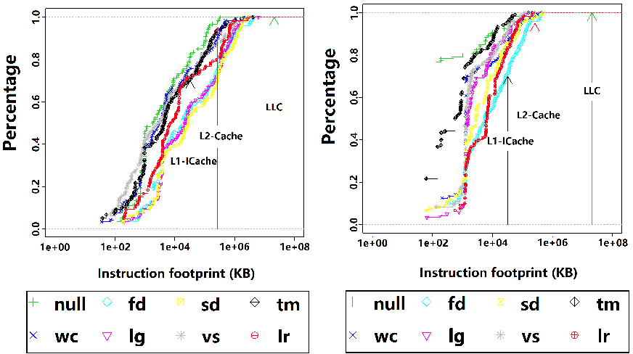

(a) Storm (b) Flink
Figure 1: Instruction footprint between two consecutive invocations of the same function.

BriskStream: Scaling Data Stream Processing on Shared-Memory Multicore Architectures (SIGMOD’19)

My previous profiling study shows that existing DSPSs underutilized the underlying complex hardware microarchitecture and especially show poor scalability due to the unmanaged resource competition among threads and unaware of the NUMA effect. Hence, my subsequent effort spends on a complete revolution in designing next-generation stream processing platform, namely BriskStream [3], specifically optimized for shared memory multicore architectures. To address NUMA effect, I have developed a new streaming execution plan optimization paradigm, namely Relative-Location Aware Scheduling (RLAS). RLAS takes the relative location (i.e., NUMA distance) of each pair of producer-consumer into consideration during optimization. In this way, it is able to determine the correlation between a solution and its objective value, e.g., predict the throughput of each operator for a given execution plan. This is different to some prior works, which assume a predefined and fixed processing capability (or cost) of each operator. Figure 3 shows the better scalability of BriskStream than existing popular DSPSs on multi-socket servers by taking Linear-Road Benchmark as an example. Unmanaged thread interference and unnecessary remote memory access penalty prevent existing DSPSs from scaling well on the modern multisockets machine. The comprehensive experiments based on two eight-sockets machines confirm that BriskStream significantly outperforms existing DSPSs up to an order of magnitude even without the tedious tuning process. In short, I showed how a DSPS, for the first time, scales stream computation towards a hundred cores under NUMA effect.

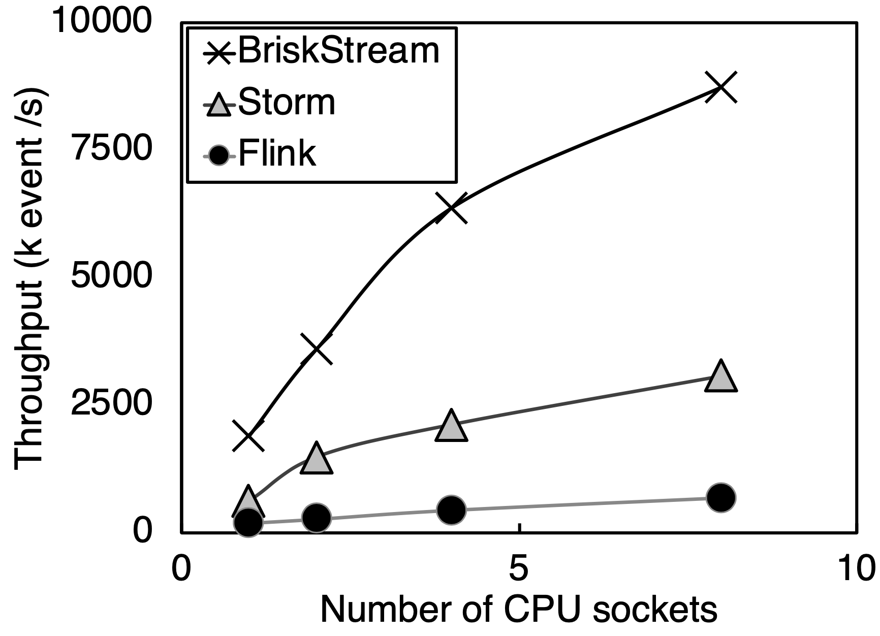
Figure 2: System scalability comparison based on Linear-Road Benchmark.

Towards Concurrent Stateful Stream Processing on Multicore Processors (To appear in ICDE’20)

DSPS with transactional state management relieves users from managing state consistency by themselves, and has recently received attention from both academia and industry community. However, scaling stream processing while providing transactional state management on modern multicore processors is challenging. On the one hand, to achieve both low latency and high throughput, DSPSs can process multiple input events (including both streaming event and ad-hoc user queries) at the same time in order to aggressively exploit parallelism. On the other hand, processing different events concurrently may lead to conflict accesses (reads and writes) to the same application state, hence leading to higher chances of violating transactional state consistency. Furthermore, more than simply guaranteeing the ACID properties preserved in the relational database systems, DSPSs further need to enforce the state access order according to the input event sequence. Witnessing those issues, I have developed TStream [6], a new DSPS that can support highly scalable stream processing with transactional state consistency guarantee on multicores. In order to take advantage of multicore architectures, TStream detaches the state management from the streaming computation logic, and performs its internal state maintenance asynchronously. By eliminating the expensive synchronization primitives, TStream aggressively extracts parallelism opportunities by revealing the operation dependencies at runtime. Figure 3 show that TStream achieves several times higher throughput on average over existing solutions (i.e., LOCK, MVLK, PAT) with similar or even smaller end-to-end processing latency. However, there is still a large room to improve TStream to achieve the performance upper bound indicated by No-Lock (i.e., without guaranteeing state consistency). We hence expect much more works to be devoted into this topic.

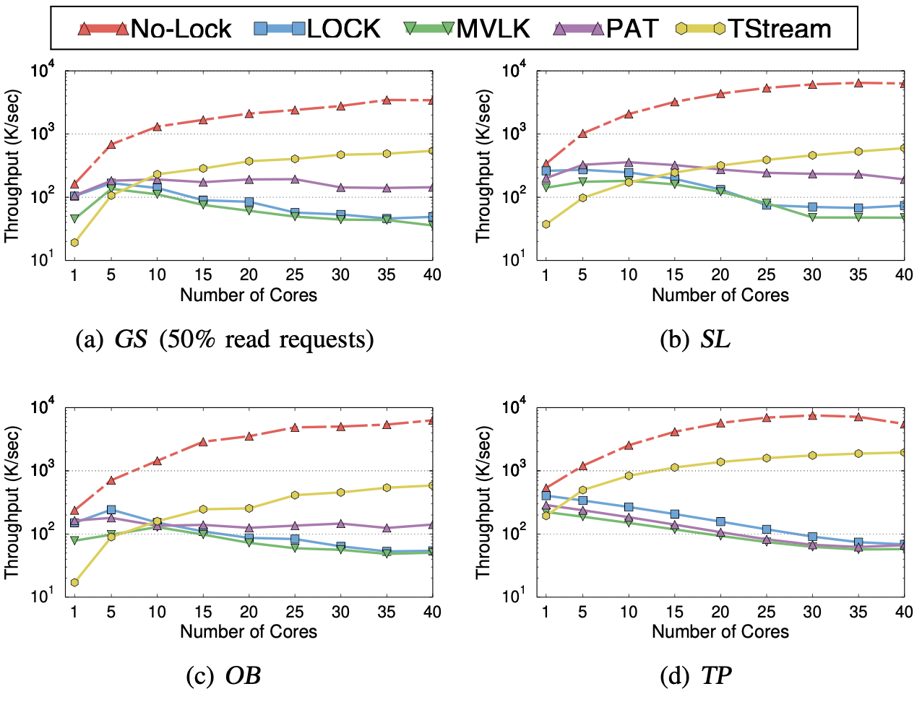
Figure 3: Performance comparison among different techniques.

References

- Shuhao Zhang, B. He, D. Dahlmeier, A. C. Zhou, and T. Heinze. Revisiting the design of data stream processing systems on multi-core processors. In Data Engineering (ICDE), 2017 IEEE 33rd International Conference on, pages 659-670. IEEE, 2017.

- Shuhao Zhang, B. He, and D. H. R. Dahlmeier. Efficient execution of data stream processing systems on multi-core processors, May 10 2018. US Patent App. 15/348,932.

- Shuhao Zhang, J. He, A. C. Zhou, and B. He. Briskstream: Scaling Data Stream Processing on Multicore Architectures. In Proceedings of the 2019 International Conference on Management of Data, SIGMOD ’19, Amsterdam, Netherlands, 2019. ACM.

- Shuhao Zhang, H. T. Vo, D. Dahlmeier, and B. He. Multi-query optimization for complex event processing in sap esp. In 2017 IEEE 33rd International Conference on Data Engineering (ICDE), pages 1213{ 1224. IEEE, 2017.

- Shuhao Zhang, H. T. Vo, D. H. R. Dahlmeier, and B. He. Multi-query optimizer for complex event processing, Apr. 24 2018. US Patent 9,953,056.

- Shuhao Zhang, Y. Wu, F. Zhang, and B. He. Towards concurrent stateful stream processing on multicore processors. To appear in ICDE ’20.

